JOBS REAL TIME LAB :

Scenario
Your company CareerBeer Technologies hosts a three-tier application on Kubernetes.
The backend application stores all business data in a MySQL database running inside the Kubernetes cluster.
Recently, a database corruption incident caused loss of important records because no automated backup mechanism was configured.
Management has asked the DevOps team to implement an automated backup solution that ensures database backups are taken regularly and stored safely for disaster recovery.

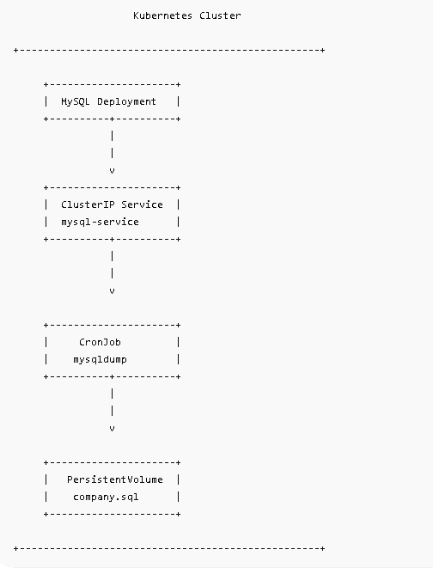

kubectl create ns backup-demo

Step 2: Create PVC
apiVersion: v1
kind: PersistentVolumeClaim
metadata:
name: backup-pvc
namespace: backup-demo
spec:
accessModes:
- ReadWriteOnce
resources:
requests:
storage: 1Gi

kubectl apply -f pvc.yaml
kubectl get pvc -n backup-demo

Step 3 Create MySQL Deployment
nano mysql-deployment.yaml
apiVersion: apps/v1
kind: Deployment
metadata:
name: mysql
namespace: backup-demo
spec:
replicas: 1
selector:
matchLabels:
app: mysql
template:
metadata:
labels:
app: mysql
spec:
containers:
- name: mysql
image: mysql:8
env:
- name: MYSQL_ROOT_PASSWORD
value: root123
- name: MYSQL_DATABASE
value: company
ports:
- containerPort: 3306

kubectl apply -f mysql-deployment.yaml

kubectl get pods -n backup-demo
Wait until running

Step 4 Create Service
nano mysql-service.yml
apiVersion: v1
kind: Service
metadata:
name: mysql-service
namespace: backup-demo
spec:
selector:
app: mysql
ports:
- port: 3306
targetPort: 3306

kubectl apply -f mysql-service.yaml
kubectl get svc -n backup-demo
o/p: mysql-service

Step 5 Insert Sample Data
Get Pod Name:
kubectl get pods -n backup-demo
Example:
mysql-7d8f4b8b7c-abcde
Connect:
kubectl exec -it mysql-7d8f4b8b7c-abcde \
-n backup-demo -- bash
Login:
mysql -uroot -proot123

Create Table
USE company;
CREATE TABLE employees(
id INT,
name VARCHAR(50)
);
INSERT INTO employees VALUES
(1,'Akshat'),
(2,'Virat');
Verify:
SELECT * FROM employees;
Output:
1 Akshat
2 Virat
Exit:
exit

Step 6 Test Connectivity From Another Pod
kubectl run mysql-client \
--rm -it \
--image=mysql:8 \
-n backup-demo \
-- bash

Inside Pod:
mysql \
-h mysql-service \
-u root \
-p

Password: root123
Verify:
SHOW DATABASES;
Success means Service connectivity works.
Exit.
Step 7 Create CronJob
nano cronjob.yaml
apiVersion: batch/v1
kind: CronJob
metadata:
name: mysql-backup
namespace: backup-demo
spec:
schedule: "*/2 * * * *"
jobTemplate:
spec:
template:
spec:
containers:
- name: backup
image: mysql:8
command:
- sh
- -c
- |
mysqldump \
-h mysql-service \
-u root \
-proot123 \
company \
> /backup/company.sql
echo "Backup Completed"
volumeMounts:
- name: backup-volume
mountPath: /backup
volumes:
- name: backup-volume
persistentVolumeClaim:
claimName: backup-pvc
restartPolicy: Never

Apply:
kubectl apply -f cronjob.yaml

Step 8 Watch CronJob
Check:
kubectl get cronjobs -n backup-demo
Watch:
kubectl get jobs -n backup-demo -w
You should see:
mysql-backup-xxxxx
created every 2 minutes.

Step 9 Verify Backup File
Launch Debug Pod:
kubectl run debug \
--image=busybox \
--rm -it \
-n backup-demo \
-- sh
This pod doesn't have PVC mounted, so instead create:

nano reader.yaml

apiVersion: v1
kind: Pod
metadata:
name: backup-reader
namespace: backup-demo
spec:
containers:
- name: reader
image: busybox
command: ["sleep","3600"]
volumeMounts:
- name: backup-volume
mountPath: /backup
volumes:
- name: backup-volume
persistentVolumeClaim:
claimName: backup-pvc

kubectl apply -f reader.yaml

Enter the pod
kubectl exec -it backup-reader \
-n backup-demo – sh

ls /backup
output:
company.sql
cat /backup/company.sql
You will see :
CREATE TABLE employees ...
INSERT INTO employees ...

